Assignment 1 - Domain-Driven Design (DDD)
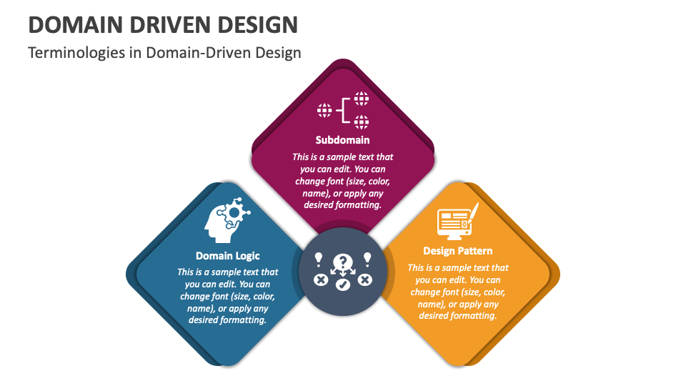

The DDD Process Steps:
- Strategic Design (The "Big Picture"):
  - Collaborate with Domain Experts: Developers and business stakeholders talk to understand the core business problems.
  - Define Ubiquitous Language: Create a shared vocabulary used by everyone, in both speech and code, to avoid ambiguity.
  - Identify Bounded Contexts: Draw clear boundaries around different parts of the business (sub-domains) to prevent a confusing, monolithic model.
- Tactical Design (The "Details"):
  - Model Entities & Value Objects: Define the core business objects. An Entity has a unique identity (e.g., a specific Customer), while a Value Object is defined by its attributes (e.g., an Address).
  - Define Aggregates: Group related entities together into a single unit for data consistency (e.g., an Order and its Order Items).
  - Implement Domain Services: Create services for business logic that doesn't naturally fit into a single entity.
Real-World Use Case: E-Commerce System
- The Problem: A monolithic system where the concept of a "Product" is confusing because it means different things to different departments.
- DDD Solution - Bounded Contexts:
  - Context A: Sales & Marketing Catalog
    - Focus: Displaying products to customers.
    - Product Model: Includes high-res images, marketing descriptions, customer reviews, and pricing.
  - Context B: Inventory & Shipping
    - Focus: Managing stock and logistics.
    - Product Model (Physical SKU): Includes weight, dimensions, warehouse location, and stock count. It doesn't care about marketing descriptions.
- Benefit: By separating these contexts, changes to the marketing catalog won't break the shipping system. The software model for each context is simpler and directly reflects the specific business needs of that department.

